How to invalidate a Measure in mClass

A measure can be invalidated, or deleted, under certain conditions such as the occurrence of an interruption during the test or testing a student under the incorrect name. Examples of interruptions include intercom announcements, fire drills, or the student becoming ill. Before invalidating a measure, contact the district Assessment Director. It is unethical to invalidate a measure because the student scored lower than expected and the purpose of invalidating the test is to increase the student score.

To invalidate a measure
- Go to the completed measure’s Results screen and select Review
- On the Review display, select Probe Not Valid. A confirmation window displays.
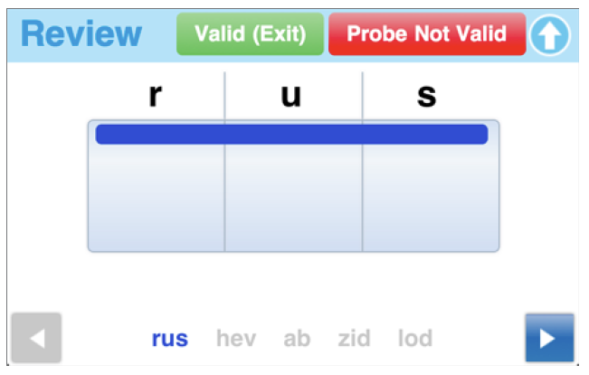
- Select Invalidate

If you invalidate a required measure, you must re-administer it to complete the benchmark assessment.

